EMPLOYEE DATA ANALYSIS
TASK-2 EDA & BUSINESS INTELLIGENCE
Statistics and Data Information
Output Bargraphs
1.Employee By Department
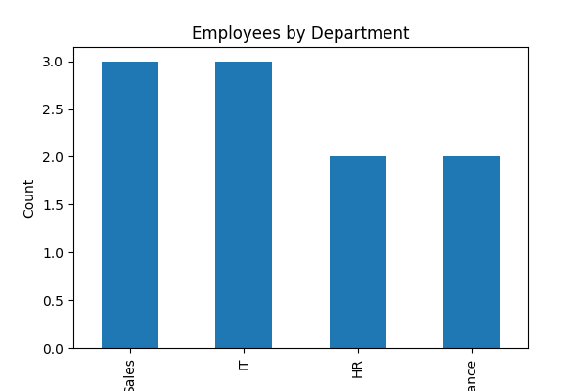
2.Performance Score

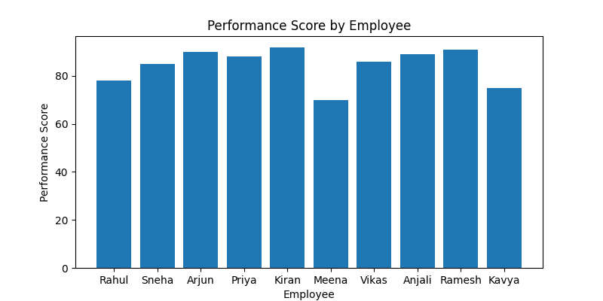

3.Employee Distribution

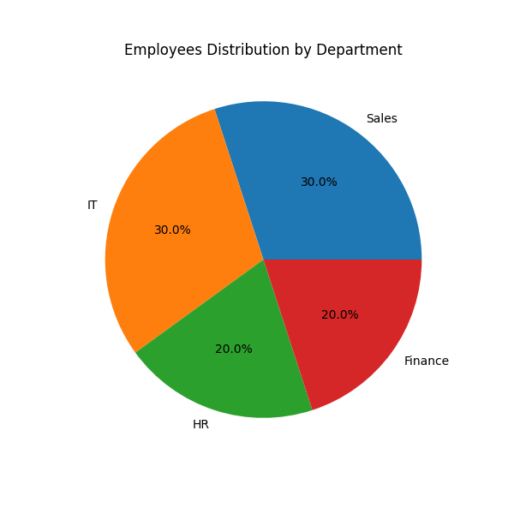

4. Experience VS Salary
